**Comoros country profile**

Published

20 July 2018

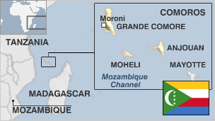

**After more than 20 coups or attempted coups, the archipelago of islands that make up Comoros are trying to consolidate political stability and use their picture-perfect beaches to climb out of poverty.**

There are four major islands, as well as many smaller ones, in the country: Grande Comore; Moheli; Anjouan; and Mayotte. Mayotte, however, voted against independence and is still governed by France.

To add to the country's troubles, two of the four major islands, Anjouan and Moheli, declared unilateral independence in a violent conflict in 1997.

The descendants of Arab traders, Malay immigrants and African peoples contribute to the islands' complex ethnic mix.

Natural resources are in short supply and the islands' chief exports - vanilla, cloves and perfume essence - are prone to price fluctuations. Money sent home by Comorans living abroad is an important source of income.

* Read [more country profiles](http://news.bbc.co.uk/1/hi/country_profiles/) - Profiles by [BBC Monitoring](http://www.bbc.co.uk/monitoring)

**President: Azali Assoumani**

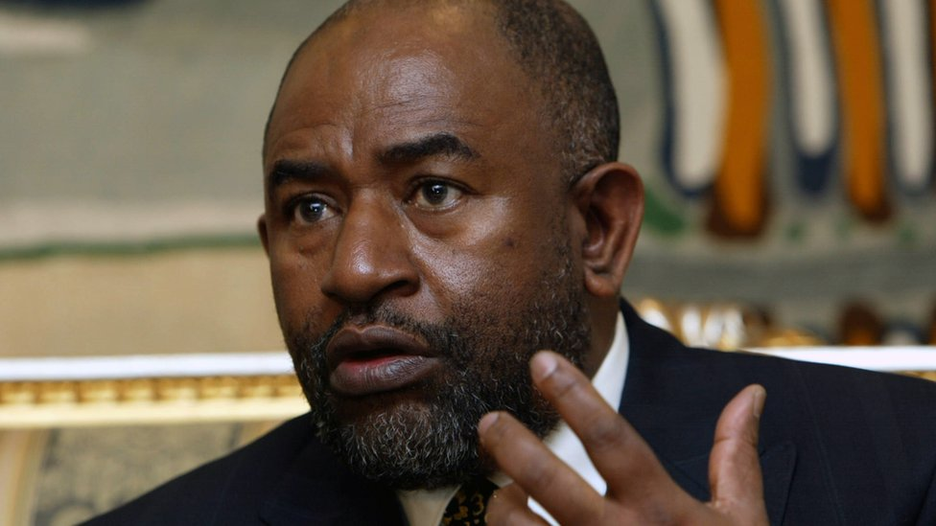image copyrightAFP

Former coup leader Azali Assoumani was declared winner of the May 2016 presidential election after violence and vote irregularities forced a partial re-run of the poll.

He succeeds outgoing President Ikililou Dhoinine after narrowly beating ruling party candidate Vice-President Mohamed Ali Soilihi by 41% of the vote to 39%.

A former army officer, Mr Assoumani first came to power in 1999, after ousting acting president Tadjiddine Ben Said Massonde in a military coup.

He won the election three years later, stepping down in 2006 at the end of his term to democratically hand over power to Ahmed Abdallah Sambi.

The presidency of the union rotates between three islands.

* The country votes in a referendum on 29 July 2018 which could change the current system - which sees power rotate every five years between the archipelago's three main islands - and enable the president to run for two fresh five year-terms. The vice president has denounced the referendum.

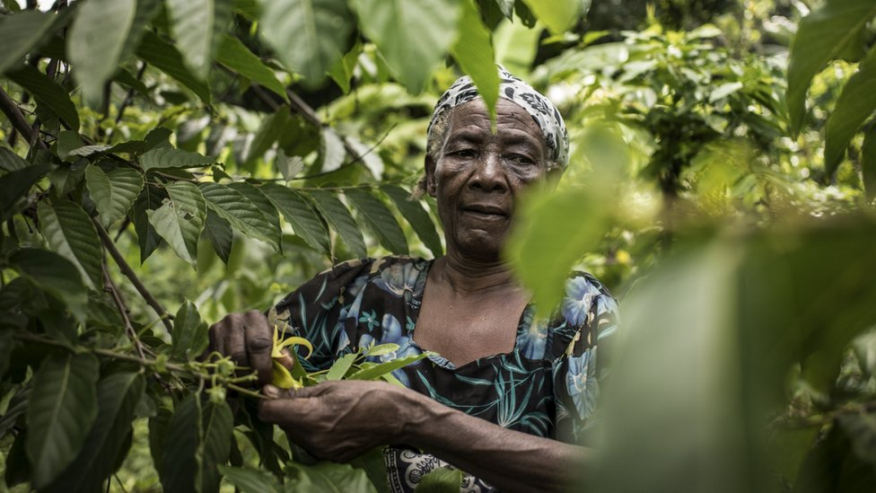image copyrightGetty Images

image captionRare Ylang-Ylang flowers are grown on the sides of the Karthala volcano for their oil which is used as a base for perfume

The Comoros authorities have a tight hold on the media in the country. Journalists risk arrest and detention, and newspapers have been suspended and radio stations put off the air over reports deemed offensive to the government.

Radio is the dominant medium. The national state-run network competes with regional services and private stations. There are also private newspaper papers. Most publish weekly; a feeble advertising market, poverty and poor distribution inhibit circulation.

# Comoros profile

Published

20 July 2018

## A chronology of key events:

**1527** - Portuguese cartographer Diego Ribero depicts the Comoros islands on a European map for the first time.

**1886** - Comoros become a French protectorate.

**1912** - Comoros formally become a French colony administered from Madagascar.

**1942** - British forces invade the Comoros and Madagascar, toppling the pro-Vichy administration and handing the territories over to the Free French government of Charles de Gaulle.

**1947** - Comoros become an overseas territory of France and are given representation in the French parliament.

**1961** - Comoros given autonomy.

## Independence

**1974** - Three of the islands making up the Comoros vote for independence, but a fourth island, Mayotte, votes to stay with France.

**1975** July - Comoros unilaterally declares independence, with Ahmed Abdallah as president.

**1975** August - Abdallah deposed in coup assisted by French mercenary Colonel Bob Denard, and replaced by Prince Said Mohammed Jaffar.

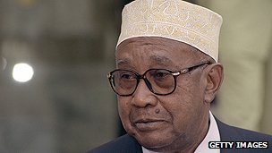image copyrightGetty Images

image captionPresident Mohamed Djohar was removed in a coup

**1976** - Jaffar replaced by Ali Soilih, who tries to turn the country into a secular, socialist republic.

**1978** - Soilih toppled and killed by mercenaries led by Denard, who restore Abdallah to power.

**1989** - Abdallah assassinated by presidential guard under command of Denard, who stages coup. France intervenes, Denard leaves islands.

**1990** - Said Mohamed Djohar elected president.

**1995** - Djohar removed in a coup attempt led by Denard. French troops intervene, Denard surrenders.

**1996** - Mohamed Abdulkarim Taki elected president, drafts a constitution which extends the authority of the president and establishes Islam as the basis of law.

## Secessionist threat

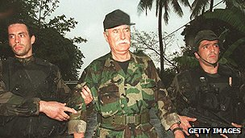image copyrightGetty Images

image captionCoup leader Bob Denard was captured by French troops

**1997** August - The islands of Anjouan and Moheli declare independence from the Comoros.

**1997** September - Troops from the island of Grande Comore land in Anjouan to try to prevent its secession, but are routed.

**1998** - President Taki dies, apparently of heart attack, and is replaced by an acting president, Tadjidine Ben Said Massounde, pending elections.

**1999** April - Massounde signs an autonomy agreement in Madagascar, but the delegates from Anjouan and Moheli refuse to follow suit, saying they must first consult their people, thereby prompting violent demonstrations in Grande Comore against people of Anjouan origins.

**1999** April - Massounde ousted in a coup led by the chief of the General Staff, Col Azali Assoumani.

**2001** March - Azali Assoumani says the country will return to civilian rule in 2002 after new institutions of government had been set up. He also said he would not stand for election.

**2001** August - A "military committee" seizes power in the breakaway island of Anjouan with aim of rejoining the Comoros.

**2001** September - In Anjouan, a day-old takeover by Major Combo Ayouba is crushed by Major Mohamad Bacar, who leads the military government set up in August.

**2001** November - Anjouan sees another failed coup attempt, this time by Colonel Said Abeid, who is against Bacar's reunification efforts.

## Autonomy for islands

**2001** December - Voters back a new constitution that will keep the three islands as one country, but will grant each one greater autonomy.

**2002** April - Colonel Mohamed Bacar elected leader of Anjouan and Mohamed Said Fazul elected leader of Moheli. Azali Assoumani named president of reunited Comoros.

**2002** May - Mze Abdou Soule Elbak is elected island president of Grande Comore, also the base of Azali Assoumani, the overall ruler of the reunited Comoros.

**2003** February - Security forces say they have foiled a coup plot against President Assoumani.

**2003** December - Leaders of semi-autonomous islands reach a power-sharing deal, paving the way for elections

**2004** March-April- Local elections for assemblies on the three semi-autonomous islands. Supporters of federal president, Azali Assoumani, win only 12 of 55 seats. Elections are held in April for 33-member national assembly - Assemblee de l'Union.

**2004** June-July- National assembly opens. President Assoumani Azali names members of first federal government.

**2005** January - First visit to France by a Comoran leader for 30 years.

**2005** April and November - Mount Karthala, one of the world's largest active volcanos, spews ash over Grande Comore. Thousands of villagers flee.

**2006 May** - Muslim cleric Ahmed Abdallah Mohamed Sambi, from Anjouan, wins federal presidential elections.

## Anjouan standoff

**2007** May - The African Union sends troops to help keep the peace in June's elections after Anjouan president Mohamed Bacar refuses to stand down.

**2007** June - Anjouan holds local elections in defiance of the federal government and the African Union. Mohamed Bacar is inaugurated as Anjouan's president.

**2007** October - The African Union imposes travel sanctions on Anjouan leader Mohamed Bacar and other government officials and freezes their foreign assets while calling for fresh elections.

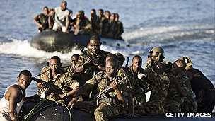image copyrightGetty Images

image captionAfrican Union troops intervened in the conflict over Anjouan island

**2007** November - AU begins naval blockade of Anjouan island.

**2008** March - Comoran and AU troops land on Anjouan and recapture it. France takes renegade leader Mohamed Bacar into custody.

**2009** March - The island of Mayotte votes to fully integrate with France. The Comoros government, which lays claim to the island, terms the referendum null and void.

**2009** May - Voters in a referendum approve extension of president's term of office. The extension is opposed by the opposition and many residents of Moheli.

**2009** June - Yemenia Airways plane crashes off Comoros, killing all but one of 153 people on board. Comoran expatriates demonstrate in France after suggestions plane may have been faulty.

**2009** December - President Sambi's party wins landslide victory in parliamentary election.

**2010** April - Libyan soldiers take up duty in the presidential guard as ''trainers''.

**2010** June - Political leaders, after some delay, agree on elections timetable starting in November with primaries for the presidency.

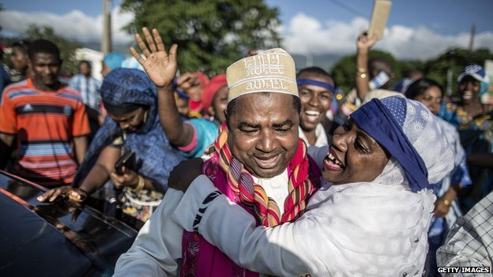image copyrightGetty Images

image captionEx-president Abdallah Sambi made preparations for a come-back and won a seat in the February 2015 parliamentary elections

**2010** December - Ikililou Dhoinine wins presidential elections, and takes office in May 2011.

**2013** April - Several people are detained, accused of plotting against the government.

**2013** November - Comoros comes out on top in a survey of women's rights in 21 Arab League states. The poll by the Thomson Reuters Foundation surveyed 336 gender experts.

**2015** February - Parliamentary elections.

**2016** May - Azali Assoumani wins the presidency after a partial election re-run.